Health Sensor App

This App is used to track the sensor info about the human health. It used body temperature, blood pressure and heart beat sensors. User can register sensor on to the cloud which run on AWS. And the sensors will send the health records to the cloud. This App help patients and doctors diagnose the health condition easily.

- Login

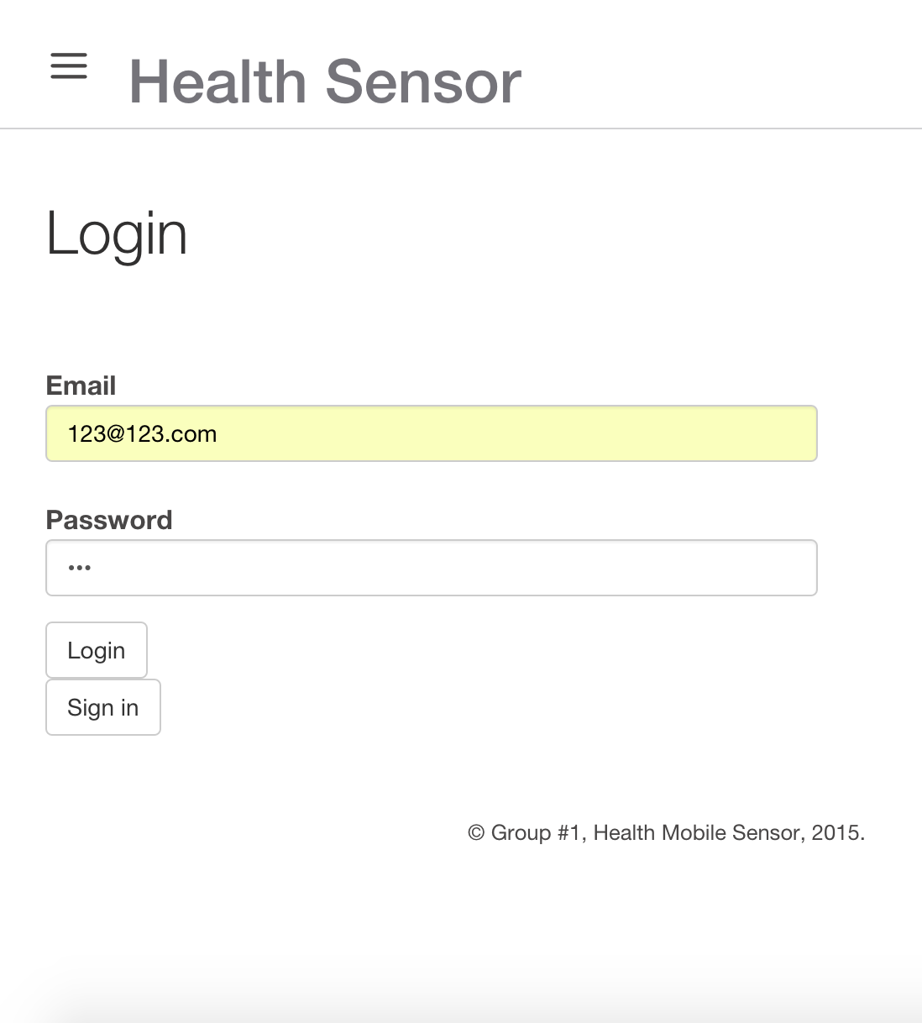

2.Menu
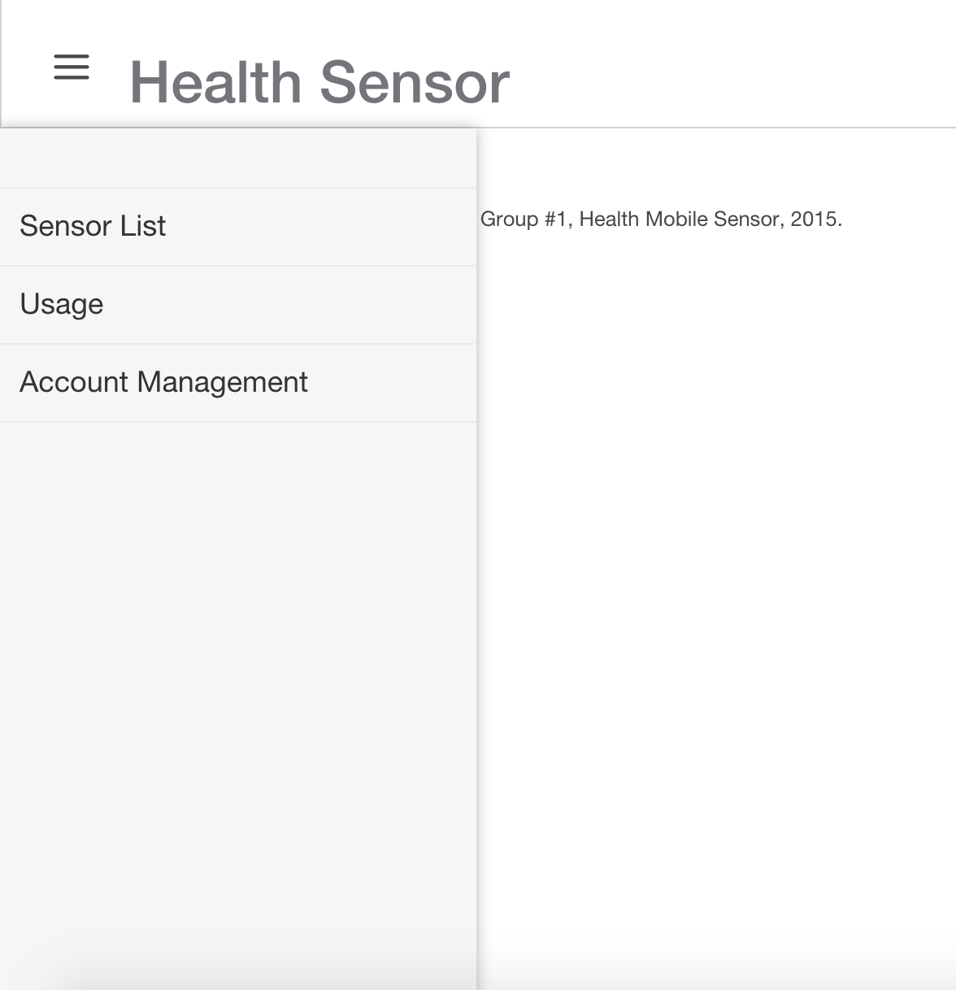

3.Add Sensor.
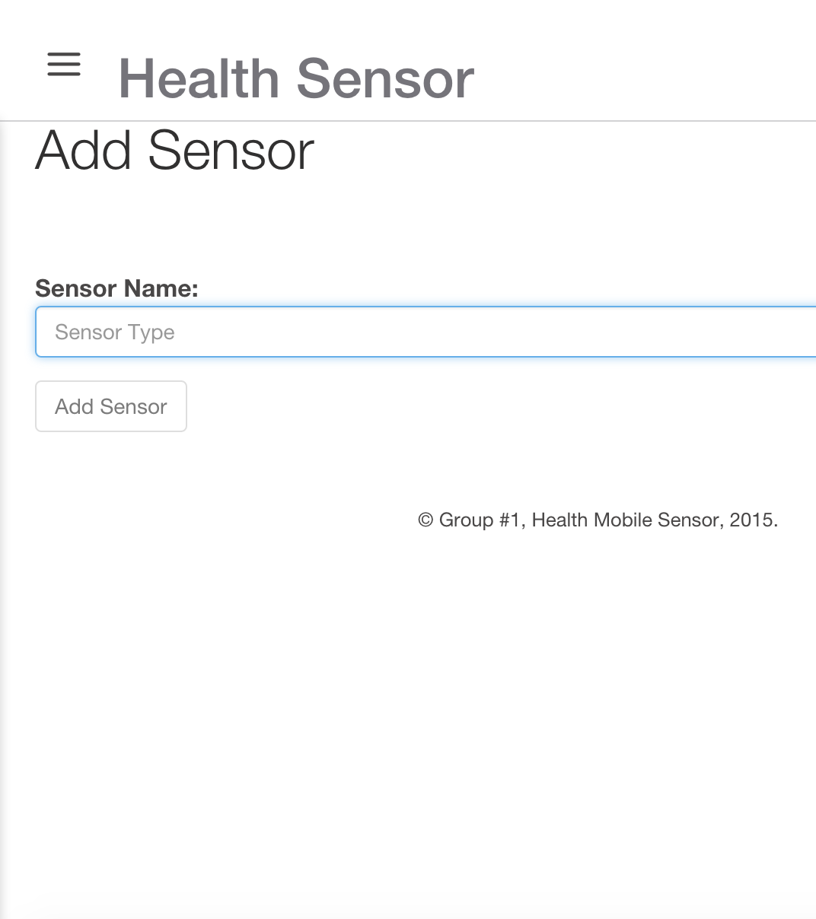

4.Sensor Dashboard.

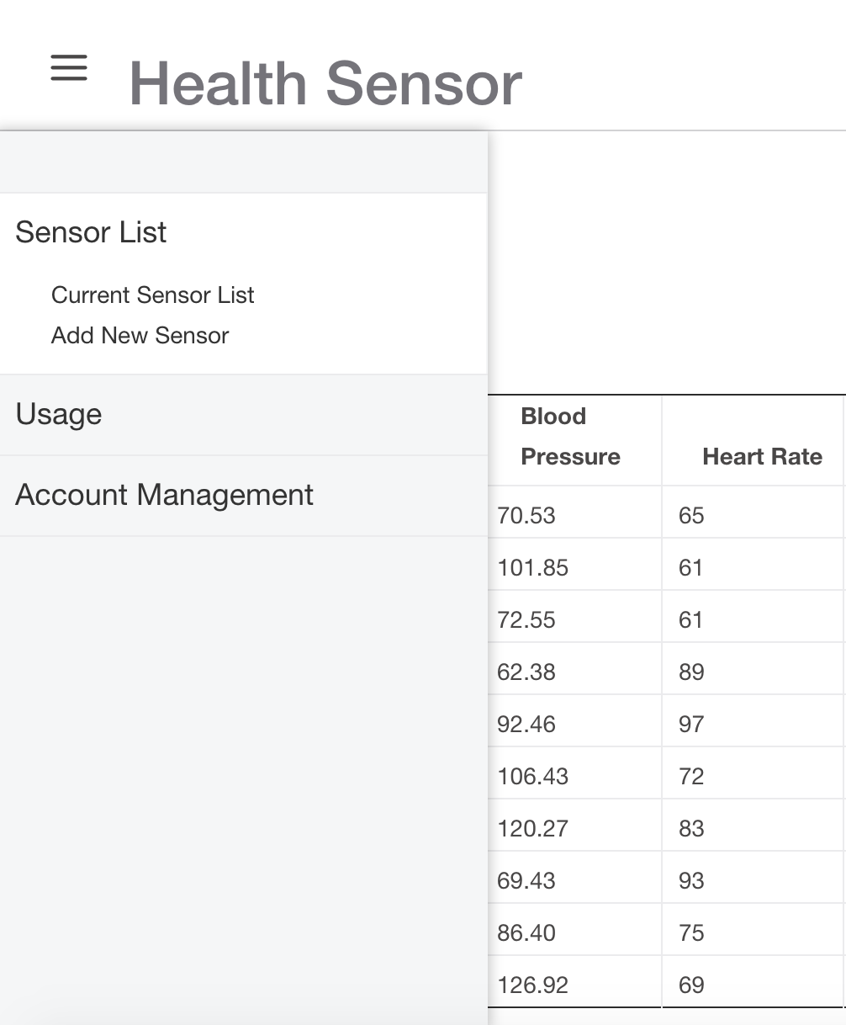

5. Pay for the sensor per request.
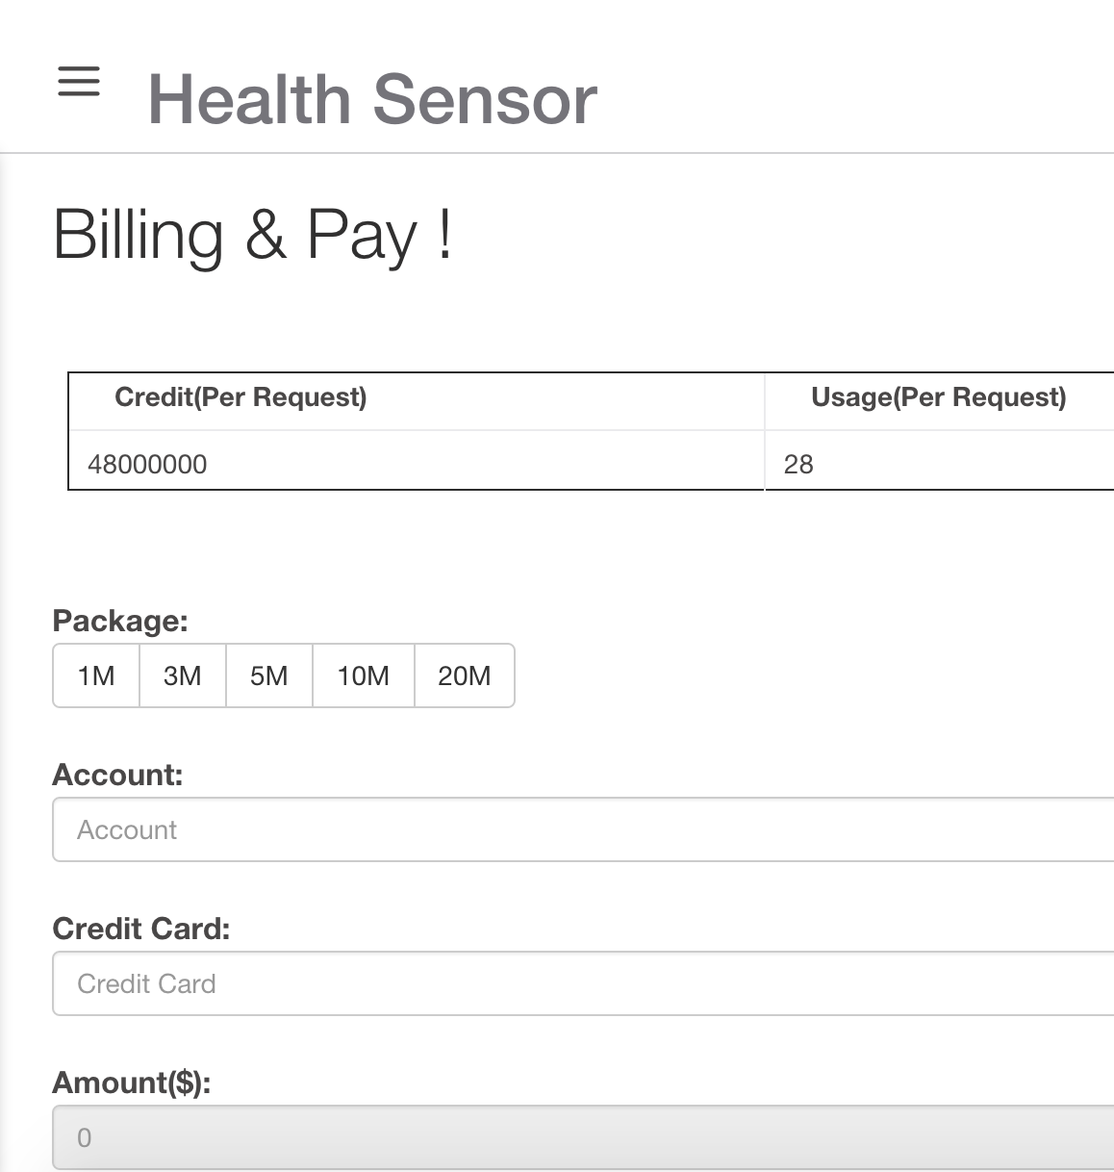

6. Living Health Sensor Data Track Image.
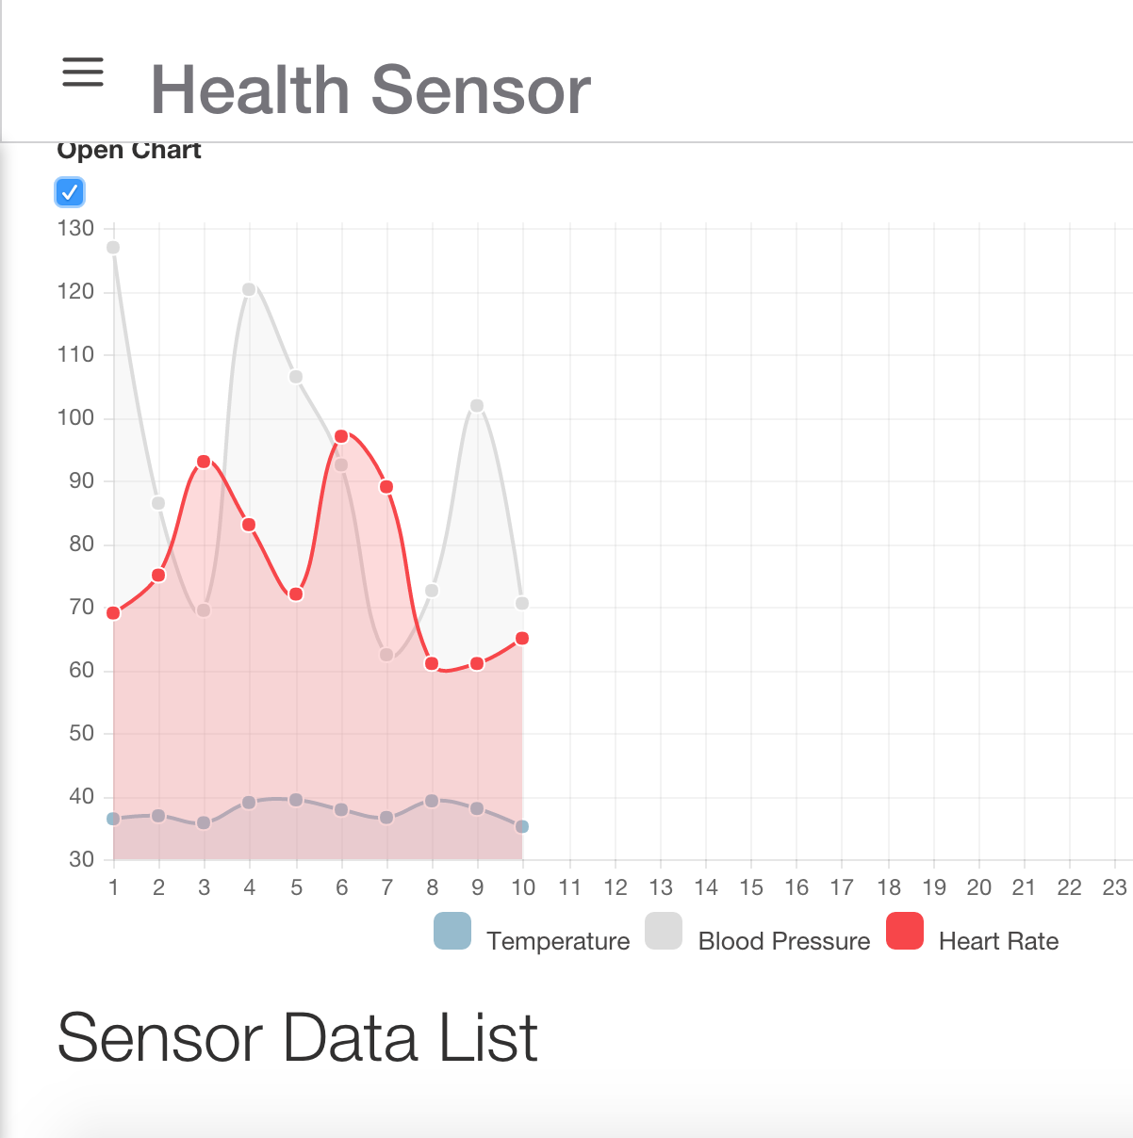

7.Sensor List
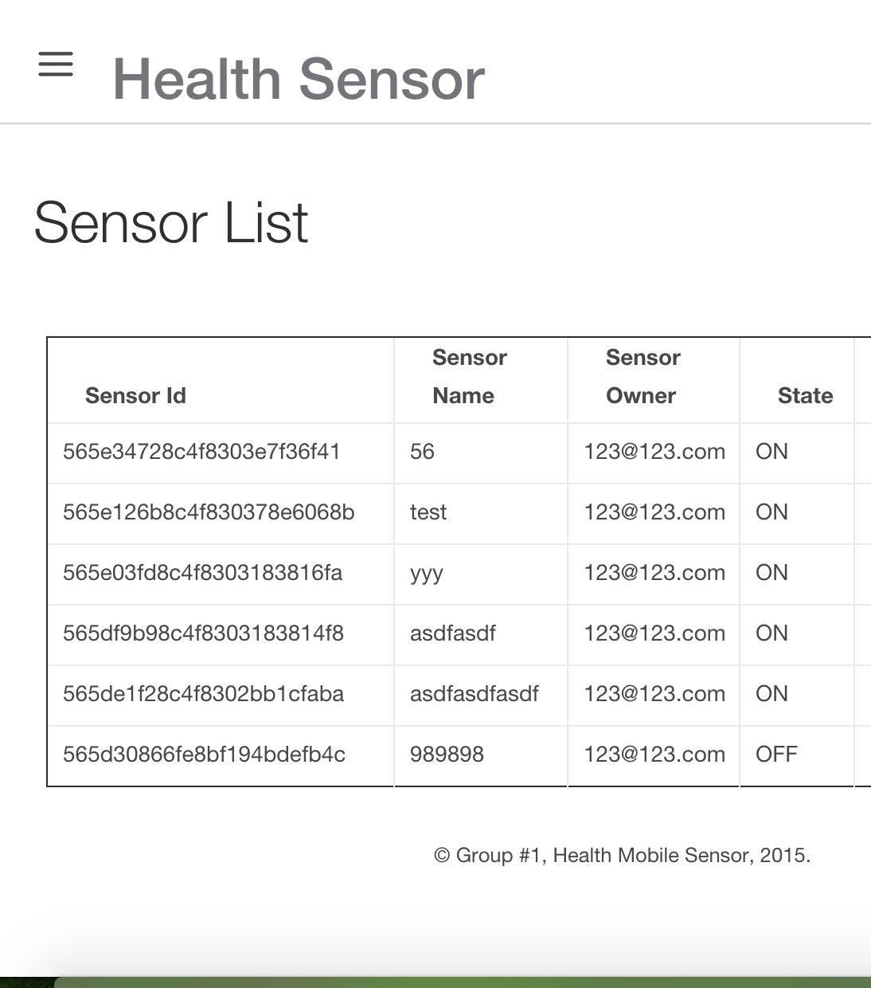

8. Sensor Real Data, It will track the data per 10 seconds.

